AI BASED DIABETES PREDICTION SYSTEM

TEAM MEMBER

815821104018:RANJITH.K

PHASE 5 SUBMISSION DOCUMENT

Project Title:AI BASED DIABETES PREDICTION SYSTEM

Phase 5: Project Documentation & Submission

Topic: In this section we will document the complete project and prepare it for submission



DIABETES PREDICTION SYSTEM

INTRODUCTION

Diabetes is a chronic medical condition that affects millions of people worldwide. It is characterized by the body's inability to regulate blood sugar levels properly, leading to various health complications. Early detection and management of diabetes are crucial in preventing these complications. To address this, the development of AI-based diabetes prediction systems has gained significant attention in recent years.

Key Components of an AI-Based Diabetes Prediction System:

Data Collection: To build an effective diabetes prediction system, a substantial amount of relevant data is required. This includes medical records, patient histories, genetics, lifestyle information, and other variables that can influence the development of diabetes.

Data Preprocessing: Raw data often needs to be cleaned, standardized, and prepared for analysis. This step involves removing errors, handling missing data, and transforming the data into a suitable format for AI algorithms.

Machine Learning Models: Various machine learning algorithms, such as logistic regression, support vector machines, neural networks, and decision trees, can be employed to analyze the data and create predictive models. These models learn from historical data and make predictions about future diabetes risk.

Feature Selection: Identifying the most relevant factors contributing to diabetes risk is crucial. Feature selection helps in determining which variables should be included in the prediction model, making it more accurate and interpretable.

Training and Testing: The AI model is trained on a portion of the available data and then tested on a separate dataset to evaluate its accuracy and generalization ability.

Risk Assessment: The system assesses the risk of diabetes for individuals by considering their personal data, health history, and lifestyle. It can provide predictions for both Type 1 and Type 2 diabetes.

User Interface: An intuitive user interface is crucial for healthcare professionals and individuals to input data, receive predictions, and access relevant information. This interface should be user-friendly and secure.

Continuous Monitoring: Diabetes prediction systems can be designed for continuous monitoring, allowing for updates and adjustments based on changing user data and healthcare guidelines.

**Dataset Link:**[**https://www.kaggle.com/datasets/mathchi/diabetes-data-set**](https://www.kaggle.com/datasets/mathchi/diabetes-data-set)

Here's a list of tools and software commonly used in the process:

Programming Languages:

1.Python: Widely used for its extensive libraries and frameworks for data analysis and machine learning, such as NumPy, Pandas, Scikit-Learn, TensorFlow, and Keras.

2.Data Collection and Preprocessing:

Electronic Health Records (EHR) Systems: For gathering patient health data.

Data Warehousing Tools: Such as SQL databases (e.g., MySQL, PostgreSQL) and NoSQL databases (e.g., MongoDB) for storing and managing healthcare data.

ETL (Extract, Transform, Load) Tools: Like Apache Nifi, Talend, or custom scripts to prepare and clean data.

Data Visualization Tools: Like Tableau, Power BI, or Python libraries such as Matplotlib and Seaborn for data exploration

3.Machine Learning Libraries and Frameworks:

Scikit-Learn: Provides a wide range of machine learning algorithms for classification and regression tasks.

TensorFlow and Keras: For building and training neural networks.

PyTorch: Another popular deep learning framework for neural network development.

XGBoost and LightGBM: Gradient boosting libraries for improving model performance.

4.Feature Engineering:

Feature Selection Tools: Such as scikit-learn's feature selection methods or dedicated feature selection libraries.

Feature Scaling and Transformation: Tools for normalizing, scaling, or transforming features, as necessary.

5.Model Evaluation:

Cross-Validation Libraries: Such as scikit-learn's StratifiedKFold for model validation.

Performance Metrics: To evaluate model accuracy, precision, recall, F1-score, ROC-AUC, etc.

6.Hyperparameter Tuning:

Grid Search and Random Search: Techniques to optimize hyperparameters.

AutoML Platforms: Such as Auto-Sklearn and H2O.ai for automated machine learning.

7.Model Deployment:

Docker: For containerizing the AI model.

Kubernetes: For orchestrating and managing containers.

Cloud Platforms: Such as AWS, Azure, Google Cloud, or specialized healthcare platforms for hosting models.

Web Frameworks: Flask, Django, or FastAPI for creating REST APIs for model access.

Model Monitoring Tools: To continuously assess model performance and data drift.

8.Data Security and Compliance:

Healthcare Data Security Tools: To ensure data privacy and HIPAA compliance.

Encryption Tools: To protect sensitive data.

9.Collaboration and Version Control:

Git: For version control.

Jupyter Notebooks: For collaborative code development and documentation.

10.Documentation and Reporting:

Jupyter Notebooks: For creating interactive reports.

Markdown Editors: For documenting the AI system's development and results.

11.Continuous Integration/Continuous Deployment (CI/CD):

CI/CD tools like Jenkins or GitLab CI for automated testing and deployment.

12.Monitoring and Logging:

Tools like Prometheus, Grafana, and ELK stack (Elasticsearch, Logstash, Kibana) for monitoring model performance and logging.

13.User Interface:

Web Development Tools: HTML, CSS, JavaScript, and front-end frameworks (e.g., React, Angular) for building user interfaces for end-users and healthcare professionals.

These tools and software are crucial for different stages of developing an AI-based diabetes prediction system, from data collection and preprocessing to model deployment and monitoring. The specific choice of tools may vary based on the project's requirements and constraints.

1.DESIGN THINKING AND PRESENT IN FORM

OF DOCUMENT

**DIABETES PREDICTION**:

The dataset comprises crucial health-related features such as 'Pregnancies', 'Glucose', 'BloodPressure', 'SkinThickness', 'Insulin', 'BMI', 'DiabetesPedigreeFunction', and 'Age'. The main objective was to predict the 'Outcome' label, which signifies the likelihood of diabetes.

**PROBLEM DEFINITION**:

The problem is to build an AI-powered diabetes prediction system that uses machine learning algorithms to analyze medical data and predict the likelihood of an individual developing diabetes. The system aims to provide early risk assessment and personalized preventive measures, allowing individuals to take proactive actions to manage their health.

**WHY USE IN DIABETES PREDICTION SYSTEM**:

Diabetes is common due to modern food intake, and it is necessary to keep track of the body. AI in Diabetes helps to predict or Detect Diabetes. Any neglect in health can have a high cost for the patients and the medical practitioner.

**DESIGN THINKING:**

Data collection: The initial step is to gather a large dataset that includes patient demographics, medical history, lab results, and other related information. This data can be obtained from electronic health records (EHRs) or other sources.

**Data preprocessing**: The collected data must be cleaned and preprocessed to eliminate any inconsistencies or missing values. The data must also be transformed and scaled to ensure machine learning algorithms can use it.

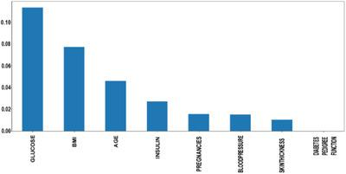

**Feature selection:** The next step is identifying the relevant features that will be used to train the machine learning model. This can include demographic information, lab results, and other related data.

**Model selection:** After the features are selected, the next step is to select the appropriate machine learning model for the task. The model type will depend on the nature of the data and the desired outcome. For example, logistic regression or a decision tree model could be used for classification tasks.

**Model training:** Once the model is selected, it needs to be trained on the collected and preprocessed data. The model will learn from the data and will be able to make predictions on new, unseen data.

**Model evaluation:** After the model is trained, it needs to be evaluated using various metrics, such as accuracy, precision, and recall. The model’s performance can be optimised by fine-tuning the hyperparameters and adjusting the features, if necessary.

**Model deployment:** Once the model is trained and optimised, it can be deployed in a production environment. The model can be integrated with existing systems, such as EHRs, to make predictions about new patients and help with the early

Detection of diabetes. 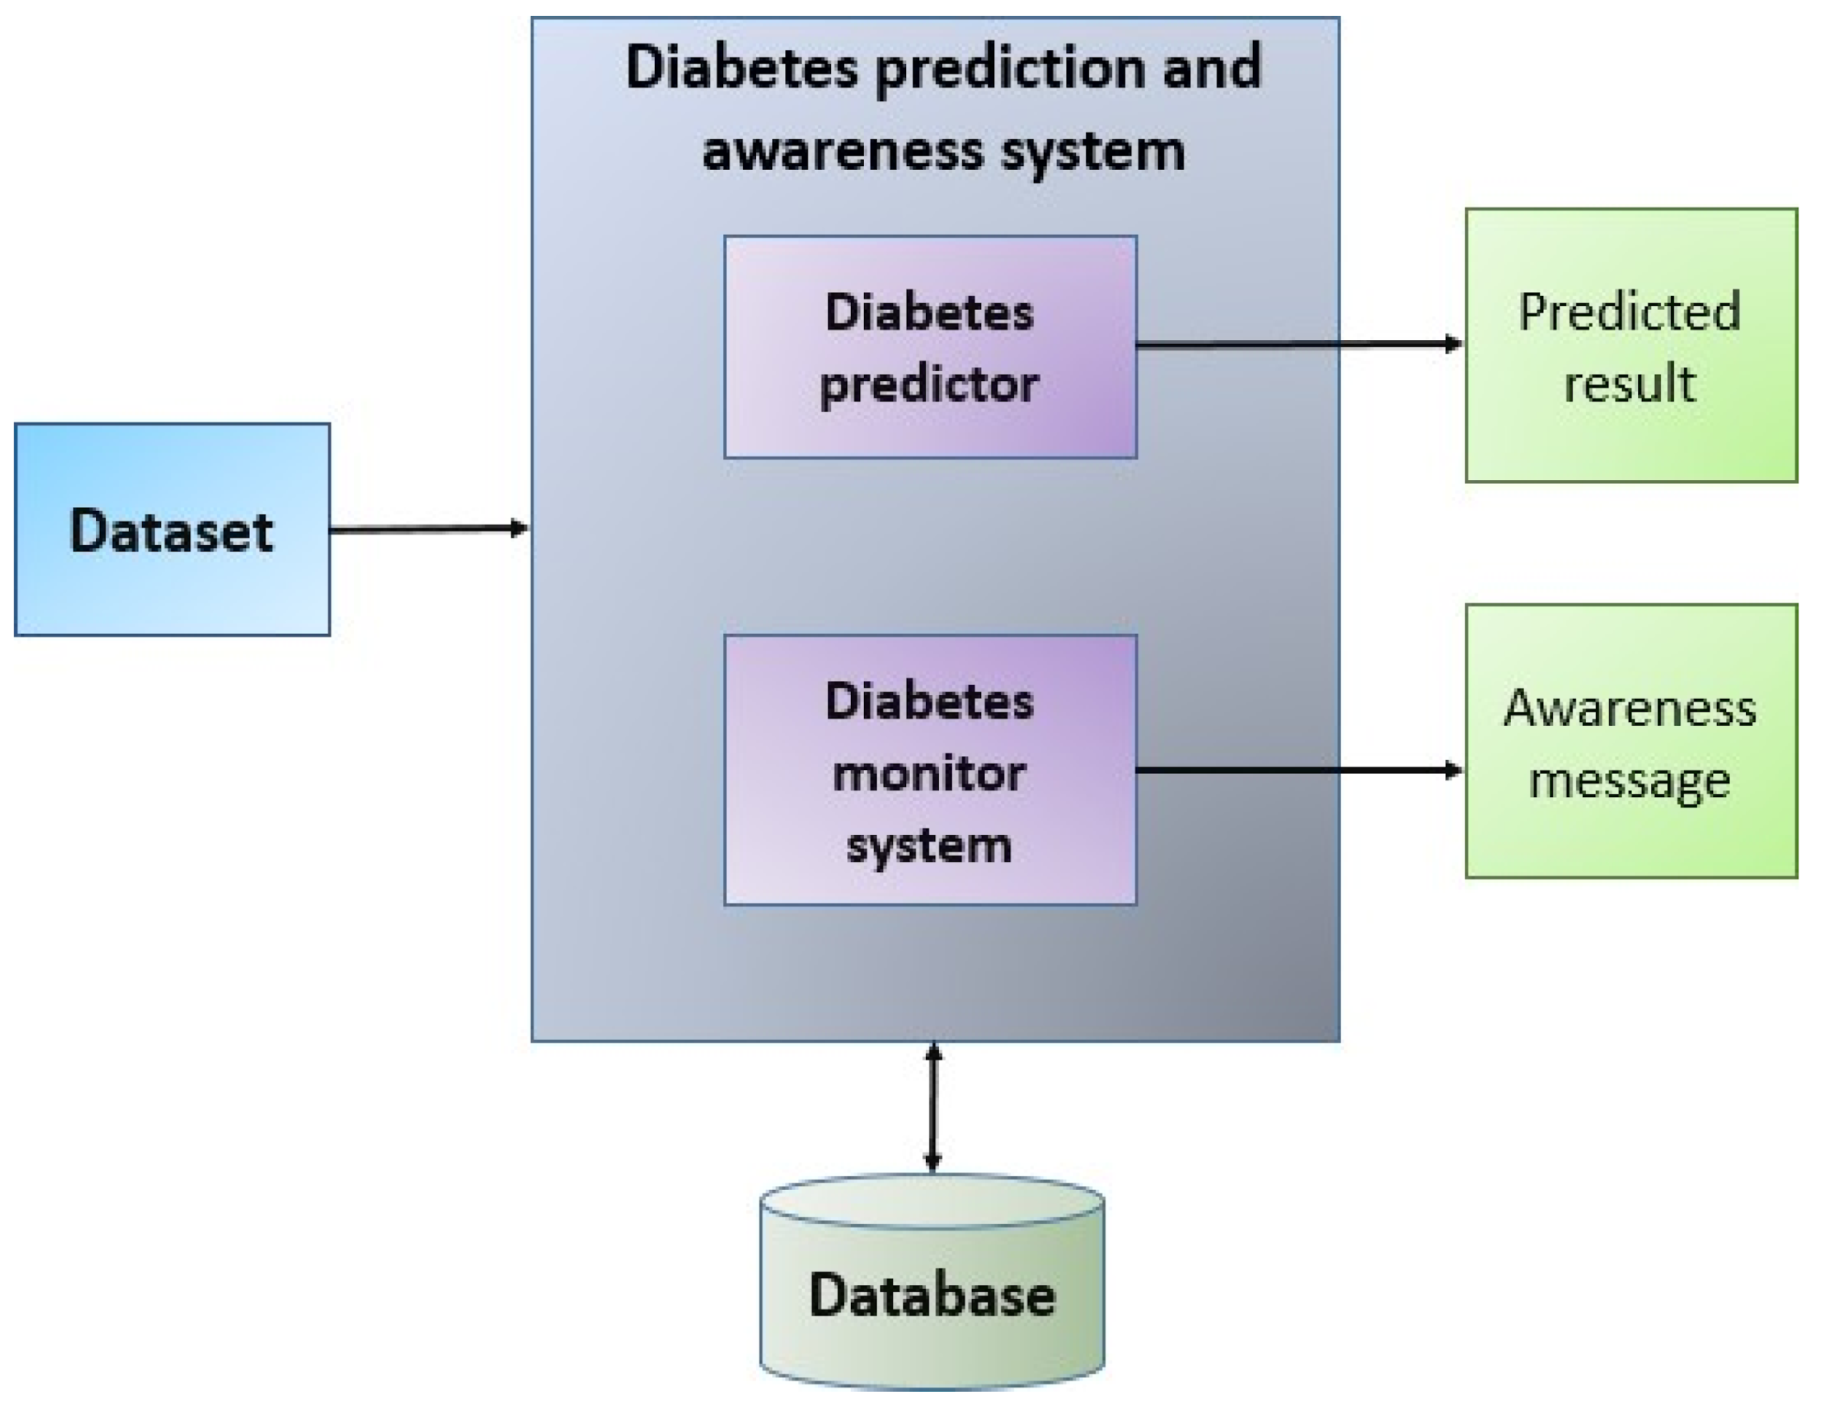

In Figure 3, the introduced system architecture is depicted. These are the steps involved in the prediction of diabetes:

**CALCULATION:**

RMSE=∑Ni=1(Predictedi−Actuali)2N−−−−−−−−−−−−−−−−−−−−−−−−√

Min–Max normalization: In this research, we used the min–max normalization technique. The data has been scaled to the same range using the following equation:

Xscaled=X−XminXmax−Xmin

where X max and X min denote maximum and minimum values in the individual feature column, respectively.

**DIABETES PREDICTION IMPORTANT:**

Long-term high blood sugar can cause chronic damage and dysfunction of various tissues, especially eyes, kidneys, heart, blood vessels and nerves.

Therefore, the early prediction of diabetes is particularly important.

Ai based diabetes prediction system in using for the library in python:

Step 1: Importing modules.

Step 2: Loading the dataset.

Step 3: Renaming the columns.

Step 4: Separating inputs and outputs.

Step 5: Train-Test split of the data.

Step 6: Building the model.

Step 7: Training and Testing of the model.

2.DESIGN INTO INNOVATION

***DATA SOURCE***:

An AI-based diabetes prediction system can be a valuable innovation in healthcare. Such a system could use machine learning and predictive analytics to identify individuals at risk of developing diabetes, allowing for early intervention and personalized healthcare. Here's a high-level overview of how you can create an innovative AI-based diabetes prediction system:

**Data Collection and Integration**:

Gather relevant healthcare data, which may include medical records, lifestyle information, genetic data, and wearable device data (such as fitness trackers and continuous glucose

monitors). Integrating data from various sources is critical for comprehensive prediction.

**Data Preprocessing**:

Clean and preprocess the data to remove noise, handle missing values, and standardize formats. This step is crucial to ensure data quality.

**Feature Selection and Engineering**:

Identify relevant features (variables) for the prediction model. Feature engineering may involve creating new variables that better represent underlying patterns related to diabetes risk.

**Machine Learning Model Selection:**

Choose appropriate machine learning algorithms for prediction, such as logistic regression, decision trees, random forests, or more advanced techniques like deep learning (e.g., neural networks).

**Model Training**:

Train the selected model using historical data, where the outcome variable is the presence or absence of diabetes. You can use techniques like cross-validation to assess model performance.

**PROGRAM:**

Importing Libraries

import numpy as np

import pandas as pd

import matplotlib.pyplot as plt

import seaborn as sns

sns.set()

from mlxtend.plotting import plot_decision_regions

import missingno as msno

from pandas.plotting import scatter_matrix

from sklearn.preprocessing import StandardScaler

from sklearn.model_selection import train_test_split

from sklearn.neighbors import KNeighborsClassifier

from sklearn.metrics import confusion_matrix

from sklearn import metrics

from sklearn.metrics import classification_report

import warnings

warnings.filterwarnings('ignore')

%matplotlib inline

Here we will be reading the dataset which is in the CSV format

diabetes_df = pd.read_csv('diabetes.csv')

diabetes_df.head()

Output:

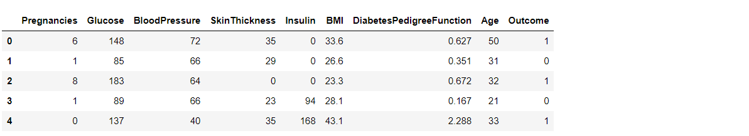

Exploratory Data Analysis (EDA):

Now let’ see that what are columns available in our dataset.

diabetes_df.columns

Output:

Index(['Pregnancies', 'Glucose', 'BloodPressure', 'SkinThickness', 'Insulin',

'BMI', 'DiabetesPedigreeFunction', 'Age', 'Outcome'],

dtype='object')

Information about the dataset

diabetes_df.info()

Output:

RangeIndex: 768 entries, 0 to 767

Data columns (total 9 columns):

# Column Non-Null Count Dtype

--- ------ -------------- -----

0 Pregnancies 768 non-null int64

1 Glucose 768 non-null int64

2 BloodPressure 768 non-null int64

3 SkinThickness 768 non-null int64

4 Insulin 768 non-null int64

5 BMI 768 non-null float64

6 DiabetesPedigreeFunction 768 non-null float64

7 Age 768 non-null int64

8 Outcome 768 non-null int64

dtypes: float64(2), int64(7)

To know more about the dataset

diabetes_df.describe()

output:

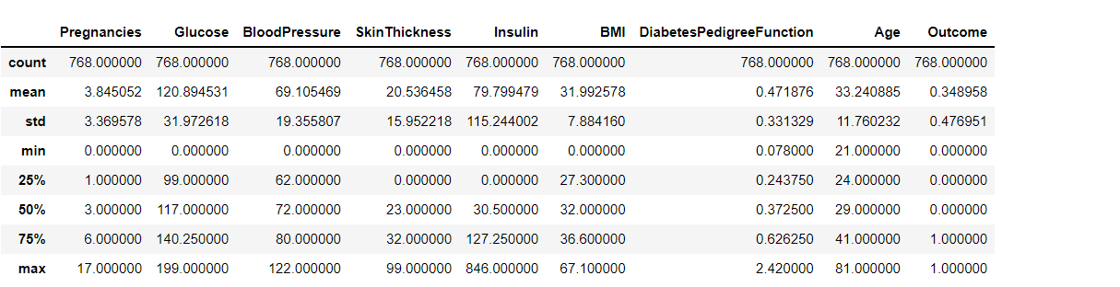

3.BUILD LOADING AND PREPROCESSING THE DATASET

PRE-PROCESSING DATASET :

**Data Collection:**

Gather a dataset containing relevant features (e.g., age, BMI, family history) and target labels (diabetes status, such as diabetic or non-diabetic).

**Data Cleaning:**

Handle missing values by imputation or removal.

Remove duplicates.

**Data Exploration:**

Analyze the dataset's statistics and distributions.

Visualize the data to gain insights.

**Feature Selection:**

Choose the most relevant features for prediction.

**Feature Engineering:**

Create new features if necessary.

Normalize or scale features.

**Data Splitting:**

Divide the dataset into training, validation, and test sets.

**Handling Class Imbalance:**

Address any imbalance in the target classes through techniques like oversampling or undersampling.

**Model Selection:**

Choose an appropriate machine learning or deep learning model for diabetes prediction.

Training:

Train the model on the training data.

Hyperparameter Tuning:

Optimize model hyperparameters for better performance.

Validation:

Evaluate the model on the validation set to fine-tune it.

Testing:

Assess the model's performance on the test set to ensure it generalizes well.

Model Evaluation:

Measure performance using metrics like accuracy, precision, recall, F1-score, and ROC AUC.

Deployment:

Deploy the AI model in a suitable environment, like a web application or mobile app.

DATASET:

In 1:

# This Python 3 environment comes with many helpful analytics libraries installed

# It is defined by the kaggle/python Docker image: https://github.com/kaggle/docker-python

# For example, here’s several helpful packages to load

Import numpy as np # linear algebra

Import pandas as pd # data processing, CSV file I/O (e.g. pd.read_csv)

Import seaborn as sns

Import matplotlib.pyplot as plt

From sklearn.model_selection import train_test_split

From sklearn import linear_model

From sklearn.metrics import r2_score,confusion_matrix

# import warnings

Import warnings

# filter warnings

Warnings.filterwarnings(‘ignore’)

# Input data files are available in the read-only “../input/” directory

# For example, running this (by clicking run or pressing Shift+Enter) will list all files under the input directory

Import os

For dirname, _, filenames in os.walk(‘/kaggle/input’):

For filename in filenames:

Print(os.path.join(dirname, filename))

# You can write up to 20GB to the current directory (/kaggle/working/) that gets preserved as output when you create a version using “Save & Run All”

# You can also write temporary files to /kaggle/temp/, but they won’t be saved outside of the current session

Load and Check Data:

In 2:

data = pd.read_csv("/kaggle/input/diabetes-prediction-dataset/diabetes_prediction_dataset.csv")

In 3:

Data.head()

In 4:

Data.info()

Output:

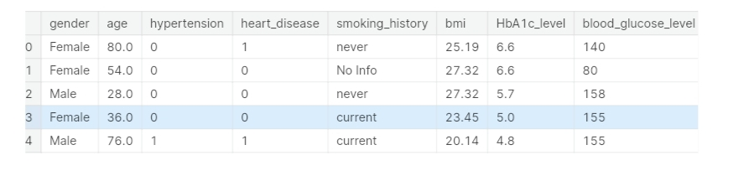

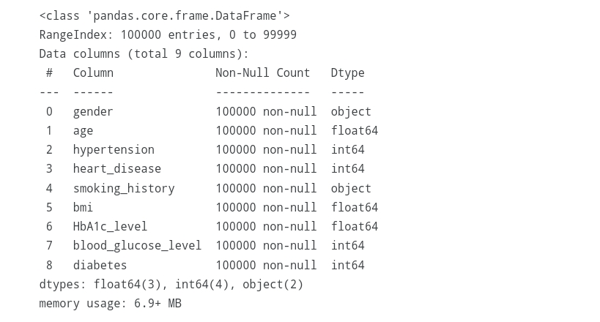

In 5:

Def bar_plot(variable):

‘’’

Input: variable ex: “Sex”

Output: bar plot & value count

‘’’

# get feature

Var = data[variable]

# count number of categorical variable(value/sample)

Var_value = var.value_counts()

# visualize

Plt.figure(figsize=(6,3))

Plt.bar(var_value.index, var_value,width= 1/(var.unique().size))

plt.xticks(var_value.index, var_value.index.values)

plt.ylabel("Frequency")

plt.title(variable)

plt.show()

print("{}: \n {}".format(variable,var_value))

In 6:

Category1 = [“hypertension”,”heart_disease”,”smoking_history”]

For c in category1:

Bar_plot(c)

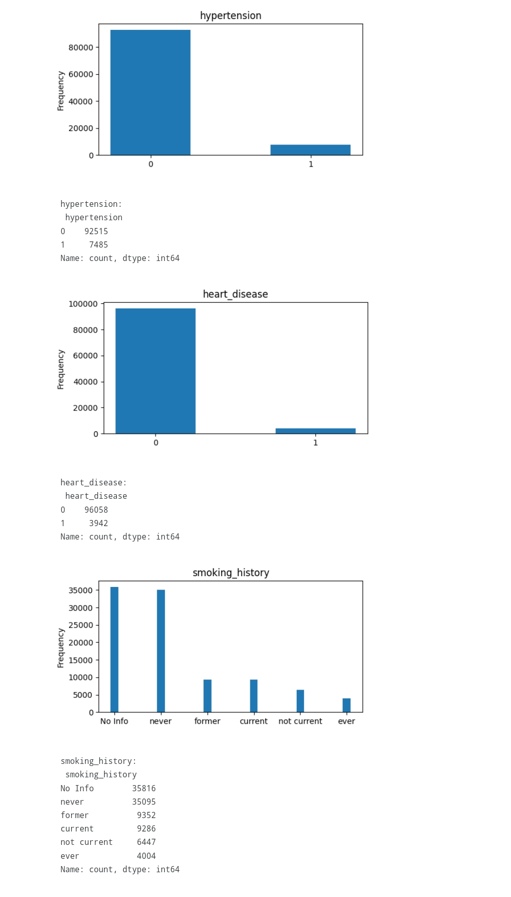

Change the Data Type:

Making data types integer

In 7:

Data.info()

In 8:

Pd.unique(data.smoking_history)

Output:

Array([‘never’, ‘No Info’, ‘current’, ‘former’, ‘ever’, ‘not current’],

Dtype=object)

In 9:

Pd.unique(data.gender)

Output:

Array([‘Female’, ‘Male’, ‘Other’], dtype=object)

In 10:

Def change_string_to_int(column):

Variables=pd.unique(data[column])

For item in range(variables.size):

Data[column]=[item if each==variables[item] else each for each in data[column]]

Return data[column]

In 11:

Data[“gender”]=change_string_to_int(“gender”)

In 12:

Data[“smoking_history”]=change_string_to_int(“smoking_history”)

In 13:

Data.head()

Output:

In 14:

Data.head()

Output 15:

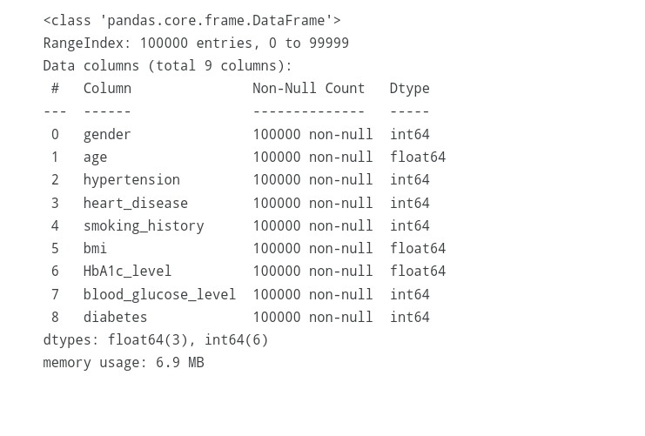

Removing from the Data:

In 15:

F,ax = plt.subplots(figsize=(10, 10))

.heatmap(data.corr(numeric_only=True), annot=True, linewidths=.5, fmt= ‘.1f’,ax=ax,)

Plt.show()

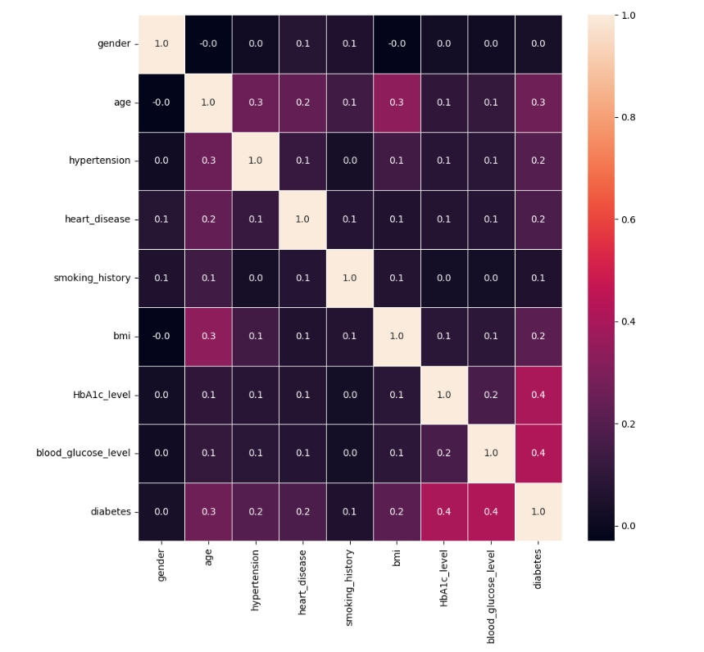

4.Different activity like feature engineering, model training, evalution etc

FEUTURE ENGINEERING:

Creating an AI-based diabetes prediction system involves several steps and considerations. Such a system can help individuals and healthcare providers identify individuals at risk of developing diabetes. Here is an outline of how you can develop a predictive system for diabetes using artificial intelligence (AI):

**1. Data Collection:**

Gather a diverse dataset that includes demographic information, medical history, lifestyle factors (e.g., diet, exercise), and relevant biomarkers (e.g., glucose levels, insulin resistance).

Ensure that the dataset is representative of the population you intend to serve.

**2.Data Preprocessing:**

Clean and preprocess the data to handle missing values, outliers, and inconsistencies.

Normalize or standardize features to ensure they are on a consistent scale.

**Feature Selection/Engineering:**

Identify the most relevant features (variables) for diabetes prediction.

Create new features if needed, such as calculating Body Mass Index (BMI) or other derived metrics.

**3.Model Selection:**

Choose an appropriate machine learning or deep learning model for prediction. Common models include logistic regression, decision trees, random forests, support vector machines, or neural networks.

**Training and Validation:**

Split your dataset into training and validation sets to train and evaluate your model.

Use techniques like cross-validation to tune hyperparameters and prevent overfitting.

**4.Model Evaluation:**

Assess the performance of your model using metrics like accuracy, precision, recall, F1 score, and area under the Receiver Operating Characteristic (ROC-AUC) curve.

**5.Model Interpretability:**

Make efforts to ensure that the model's predictions are interpretable and can be understood by healthcare professionals and patients.

**6.Deployment**:

Integrate the model into a user-friendly interface for healthcare providers or individuals. This could be a web or mobile application.

Ensure that the system is compliant with relevant data privacy and healthcare regulations (e.g., GDPR or HIPAA).

**7.Continuous Monitoring and Updates:**

Regularly update the model with new data to maintain its predictive accuracy.

Monitor its performance and make necessary adjustments as more data becomes available.

**8.Education and Outreach:**

Provide information and resources to healthcare professionals and individuals to help them understand the predictions and take appropriate actions.

**9.Ethical Considerations:**

Ensure that the system is designed and used ethically and that potential biases are addressed.

**10.User Feedback and Improvement**:

Collect feedback from users and healthcare professionals to improve the system continually.

MODEL TRAINING:

Training an AI-based diabetes prediction system involves using a machine learning model to learn patterns and relationships within your dataset. Below, I'll outline the steps involved in training such a model:

**➢ Data Preparation:**

Start with a well-preprocessed dataset that includes features and labels. In your case, features would be patient data (e.g., age, BMI, blood pressure, family history) and labels would indicate whether a patient has diabetes (1 for yes, 0 for no).

**➢ Data Splitting:**

Split your dataset into two or three subsets: a training set, a validation set, and, if available, a test set. The training set is used to train the model, the validation set to tune hyperparameters, and the test set to evaluate the final model.

**➢ Model Selection:**

Choose an appropriate machine learning algorithm for binary classification. Common choices include logistic regression, decision trees, random forests, support vector machines, and neural networks.

**➢ Feature Scaling:**

Normalize or standardize your features so they have similar scales. This helps models converge faster and perform better.

**➢ Model Training:**

Train your chosen model on the training dataset. The model learns the patterns in the data and optimizes its parameters to make predictions.

**➢ Hyperparameter Tuning:**

Use the validation set to fine-tune hyperparameters, such as learning rates, regularization strengths, or the maximum depth of a decision tree. Grid search or random search can be helpful.

**➢ Model Evaluation:**

After hyperparameter tuning, assess your model's performance on the validation set using appropriate metrics like accuracy, precision, recall, F1 score, or ROC-AUC.

**➢ Model Testing:**

Once you're satisfied with the model's performance on the validation set, evaluate it on the test set to get an unbiased estimate of its generalization performance.

PY:

# Import necessary libraries

import pandas as pd

from sklearn.model_selection import train_test_split

from sklearn.preprocessing import StandardScaler

from sklearn.linear_model import LogisticRegression

from sklearn.metrics import accuracy_score, classification_report

# Load your dataset (replace 'your_dataset.csv' with your actual dataset file)

data = pd.read_csv('your_dataset.csv')

# Split the data into features (X) and labels (y)

X = data.drop('diabetes_label', axis=1) # Adjust column name

y = data['diabetes_label'] # Adjust column name

# Split the data into training and testing sets

X_train, X_test, y_train, y_test = train_test_split(X, y, test_size=0.2, random_state=42)

# Standardize features (normalize them)

scaler = StandardScaler()

X_train = scaler.fit_transform(X_train)

X_test = scaler.transform(X_test)

# Initialize the machine learning model (Logistic Regression in this example)

model = LogisticRegression()

# Train the model

model.fit(X_train, y_train)

# Make predictions on the test data

y_pred = model.predict(X_test)

# Evaluate the model

accuracy = accuracy_score(y_test, y_pred)

report = classification_report(y_test, y_pred)

print(f"Accuracy: {accuracy}")

print(report)

EVALUATION ETC AS PER INSTRUCTION:

**1.Data Splitting:**

Split your dataset into three subsets: a training set, a validation set, and a test set. The training set is used for model training, the validation set for hyperparameter tuning, and the test set for final evaluation.

**2.Model Selection and Training:**

Choose a machine learning model (e.g., Logistic Regression, Decision Trees, or Neural Networks) and train it on the training data.

# Assuming you've already loaded and preprocessed your data as in the previous example

from sklearn.model_selection import train_test_split

from sklearn.metrics import accuracy_score, precision_score, recall_score, f1_score, roc_auc_score

# Split the data into training, validation, and test sets

X_train, X_valid, y_train, y_valid = train_test_split(X_train, y_train, test_size=0.2, random_state=42)

# Train the model on the training data

model.fit(X_train, y_train)

**3.Hyperparameter Tuning**:

Tune hyperparameters on the validation set to optimize the model's performance.

# Hyperparameter tuning (example for Logistic Regression)

from sklearn.model_selection import GridSearchCV

param_grid = {'C': [0.001, 0.01, 0.1, 1, 10, 100]} # Example hyperparameters for tuning

grid_search = GridSearchCV(model, param_grid, cv=5)

grid_search.fit(X_valid, y_valid)

# Use the best parameters for the final model

best_model = grid_search.best_estimator_

4.Model Evaluation:

Evaluate the final model on the test set using appropriate evaluation metrics. Common metrics for binary classification include accuracy, precision, recall, F1 score, and ROC-AUC.

# Evaluate the final model on the test set

y_pred = best_model.predict(X_test)

accuracy = accuracy_score(y_test, y_pred)

precision = precision_score(y_test, y_pred)

recall = recall_score(y_test, y_pred)

f1 = f1_score(y_test, y_pred)

roc_auc = roc_auc_score(y_test, y_pred)

print(f"Accuracy: {accuracy}")

print(f"Precision: {precision}")

print(f"Recall: {recall}")

print(f"F1 Score: {f1}")

print(f"ROC-AUC Score: {roc_auc}")

**5.Model Interpretability (Optional):**

Depending on the model, you may want to analyze feature importance to understand which features are driving the predictions.

**6.Ethical and Compliance Check:**

Ensure that the model's predictions adhere to ethical and legal guidelines, especially when dealing with sensitive healthcare data.

**7.User Education and Interaction:**

Provide healthcare providers and patients with information on how to interpret and use the model's predictions effectively.

**8.Monitoring and Maintenance:**

Continuously monitor the model's performance in a production environment and retrain it periodically with new data to keep it up to date.

**Advantages:**

**Early Detection:** AI can identify diabetes risk factors and predict the likelihood of diabetes before symptoms manifest. This enables early intervention and lifestyle modifications.

**Personalization:** These systems provide personalized recommendations and insights tailored to an individual's health data, promoting patient engagement and adherence to healthcare plans.

**Improved Healthcare Management:** AI can help healthcare providers in optimizing patient care by identifying high-risk patients and customizing treatment plans accordingly.

**Reduced Healthcare Costs:** Early detection and prevention can lead to cost savings by reducing the need for extensive treatments and hospitalizations.

**Continuous Monitoring:** AI can provide ongoing monitoring, allowing for dynamic adjustments to treatment and lifestyle plans as health conditions change.

**Data-Driven Insights:** AI systems can analyze vast amounts of data, uncovering hidden patterns and risk factors that may not be evident through traditional methods.

**Scalability:** AI models can be scaled to handle large patient populations, making them valuable for public health initiatives and research.

Disadvantages:

**Data Privacy and Security:** Collecting and storing sensitive health data raises concerns about privacy and security. Unauthorized access or data breaches could have serious consequences.

**Data Bias:** If training data is biased or unrepresentative, AI models may provide inaccurate predictions, leading to healthcare disparities and misdiagnoses.

**Model Explainability:** Some AI models, particularly deep learning models, are considered "black boxes" because they are challenging to interpret. Understanding the rationale behind predictions is crucial for healthcare decision-making.

**Validation and Accuracy:** The accuracy of AI predictions can vary based on data quality and model complexity. Ensuring high accuracy and generalizability is a significant challenge.

**Regulatory Compliance:** Developing AI-based healthcare systems requires adherence to strict regulatory standards, such as HIPAA in the United States and GDPR in Europe. Compliance can be a complex and resource-intensive process.

**Healthcare Professional Acceptance:** Some healthcare professionals may be hesitant to rely solely on AI predictions, which can impact the adoption of these systems in clinical practice.

**Technical Challenges:** Developing and maintaining AI-based systems requires technical expertise, and healthcare institutions may need to invest in specialized talent and infrastructure.

**Resource Intensive:** Building and maintaining AI systems can be costly, especially for smaller healthcare providers or resource-constrained regions.

**Limited Access:** In some regions or among underserved populations, access to AI-based healthcare services may be limited due to the digital divide, lack of infrastructure, or economic factors.

**Ethical Concerns:** There are ethical concerns related to how AI predictions may impact patient autonomy and decisions about treatment and insurance coverage.

In summary, AI-based diabetes prediction systems have the potential to revolutionize diabetes care and prevention, but they also come with significant challenges related to data privacy, bias, regulatory compliance, and healthcare provider acceptance. It's crucial to carefully address these issues and ensure that the benefits of these systems outweigh the disadvantages.

**Conclusion:**

In conclusion, AI-based diabetes prediction systems are transformative tools in the field of healthcare that hold the potential to significantly improve the management and prevention of diabetes. These systems offer numerous advantages, including early detection, personalized recommendations, improved healthcare management, and cost reduction. They can empower patients to take control of their health and assist healthcare providers in delivering more targeted and effective care.

However, there are challenges to address, such as data privacy, bias, model explainability, and regulatory compliance. As the technology continues to evolve, it is essential to strike a balance between harnessing the capabilities of AI and ensuring ethical and responsible use in healthcare.

In the face of these challenges, the development and implementation of AI-based diabetes prediction systems have the potential to make a profound impact on public health by reducing the burden of diabetes and enhancing the quality of life for those at risk. With careful consideration of the advantages and disadvantages, these systems can contribute to a future where diabetes is better managed and prevented, ultimately improving the well-being of individuals and healthcare systems worldwide

Prepared by…

RANJITH.K